**Assignment 1 – Intro to Web Programming**

This assignment requires you to insert and select data from a database and validate user inputs using PHP scripting. Your mark counts for 15% of your final grade.

Due Date:  **Wednesday, Feb 12 @ 5:00 pm**

**Submission Requirements via Blackboard:**

* a link to your *private* **comp1006-as1** repo (invite me – ifotn – as collaborator)
* the url’s to your pages on the AWS web server so that I can run them

All work must be your own. Failure to submit an independent assignment will result in a grade of zero.

You may use my Blackboard files as a reference but you MUST WRITE YOUR CODE FILES. I will not mark my own work. If I can tell that you have simply taken my in-class files from Blackboard and changed the words you will not receive a mark.

Note the screenshots at the end of this document are an example only. You must build a different application from the one I have used as a sample.

# Description: Student-Chosen Web Application

You may choose the subject of your web site. The purpose of your site should be something that is of interest to you, so long as it meets the requirements below. Some examples are:

* Web site registration & user list
* Sports team manager
* Online music tracker (e.g. iTunes)
* Task manager
* Family Household Chore tracker

In this assignment you will use PHP, HTML, and SQL to:

* Design 2 or more database tables
* Build a form to capture user input. This form must include a dropdown filled from the database.
* Validate user input
* Save data to a database table
* Query the database and output the data into an HTML table
* Document your code with comments within your scripts

**Application Requirements:**

1. Document each section of your PHP scripts with comments. You do not need to document every single line.
2. Create 2 tables in your AWS database - 1 to store the user inputs from your HTML form and 1 used to populate a dropdown list on your you need on your input form
3. Create a minimum of 1 input form that includes:
   1. Input controls for each of the field in your database table listed above
   2. At least 1 dropdown list that is populated from a table in your database (this means the page will need a .php extension)
   3. Proper HTML5 input validation in your form controls
4. Create a PHP page that accepts a form POST from #3 above. The PHP page should:
   1. Verify that values have been entered in each field and show a message to the user about any missing inputs
   2. Save the data to the database if all the input data is valid
5. Create a PHP page that shows data from the database in an HTML table.
6. Deploy your site to the AWS web server
7. Commit your code to a private GitHub repository:
   1. Invite me – ifotn – as a collaborator
   2. Show a minimum of 4 commits, each with a descriptive name (not “Commit 1”, “Commit 2”, etc.
   3. Create a README.md file that describes what your application does and includes a link to the live web site

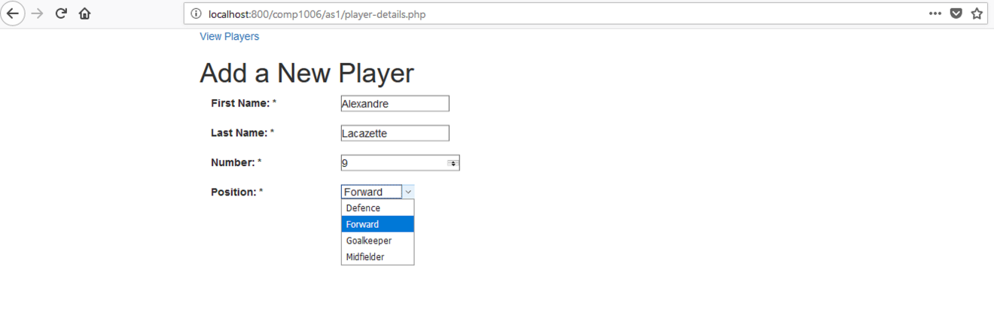

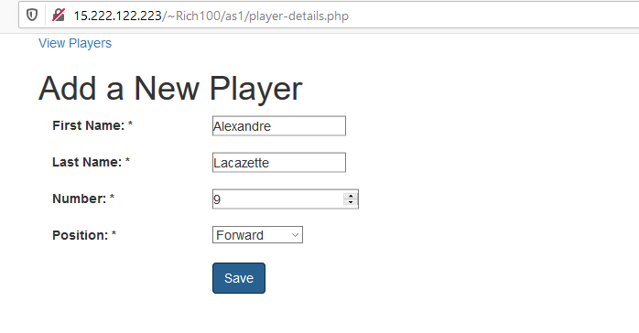

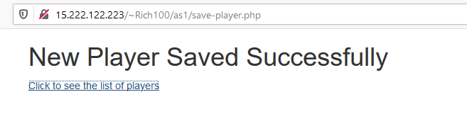

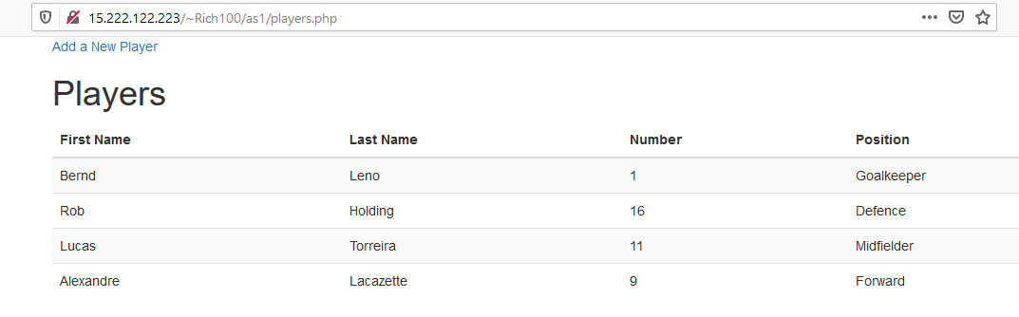

**Evaluation Method**

Your work will be evaluated based on how your PHP scripts perform when I load and try your web pages from the AWS web server.

# Evaluation Criteria (max 30 marks + 2 possible bonus marks)

|  |  |  |  |  |  |
| --- | --- | --- | --- | --- | --- |
| **Criteria** | **0-2** | **3-4** | **5-6** | **7-8** | **Marks** |
| **Create Tables** | - Little no tables | - Partly complete tables | - Mostly complete, mostly logical data types | - Complete, well-designed tables with good use of data types | **2** |
| **Insert Data** | - No create | - Some create code correct | - Most create | - All functioning create | **8** |
| Query Data for dropdown & HTML table | - No queries | - Some queries & output correct | - Most queries & output correct | - All functioning queries & output | **8** |
| Validate Data | - No validation | - Some validation | - Most validation working | - Fully functioning validation on both the client and server | **8** |
| **Version Control** | None | Attempted | Mostly complete | Complete. Min 4 commits, descriptively named with README.md file explaining your site and containing link to live site | **2** |
| **Code Commenting** | - No comments | - Some attempt to explain code | - Most sections clearly explained | - All sections clearly explained | **2** |
| **\*\*\* WILD-CARD BONUS \*\*\*** |  |  |  | - Up to 2 bonus marks for any additional working PHP functionality of your choosing that shows independent learning. | **2** |